Integers
A whole number, from zero to positive or negative infinity is called Integers. I.e. it is a set of numbers which include zero, positive natural numbers and negative natural numbers. It is denoted by letter Z.
Z = {…,-2,-1, 0, 1, 2…}

Integers on Number Line
On the number line, for positive integers we move to the right from zero and for negative integers move to the left of zero.
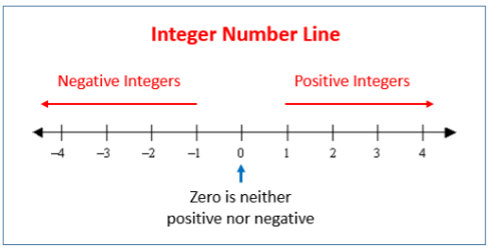

Facts about how to Add and Subtract Integers on the Number Line
1. If we add a positive integer, we go to the right.
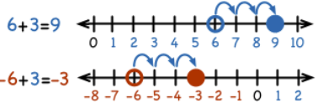
2. If we add a negative integer, we go to the left.
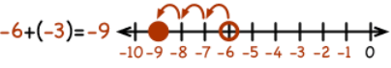
3. If we subtract a positive integer, we go to the left.
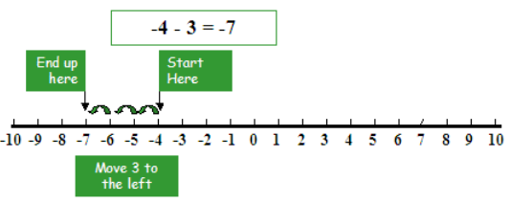
4. If we subtract a negative integer, we go to the right.
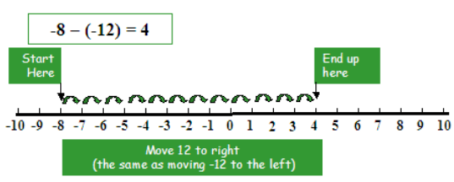

Rules of addition of integers
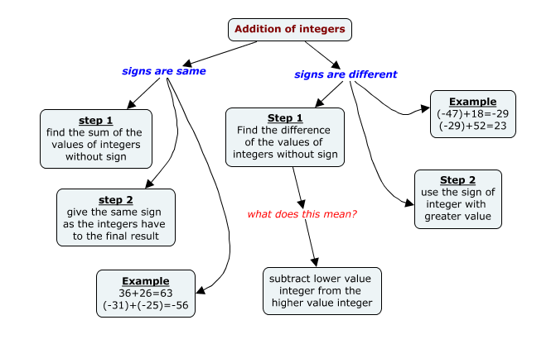

Rules for subtraction of integers
